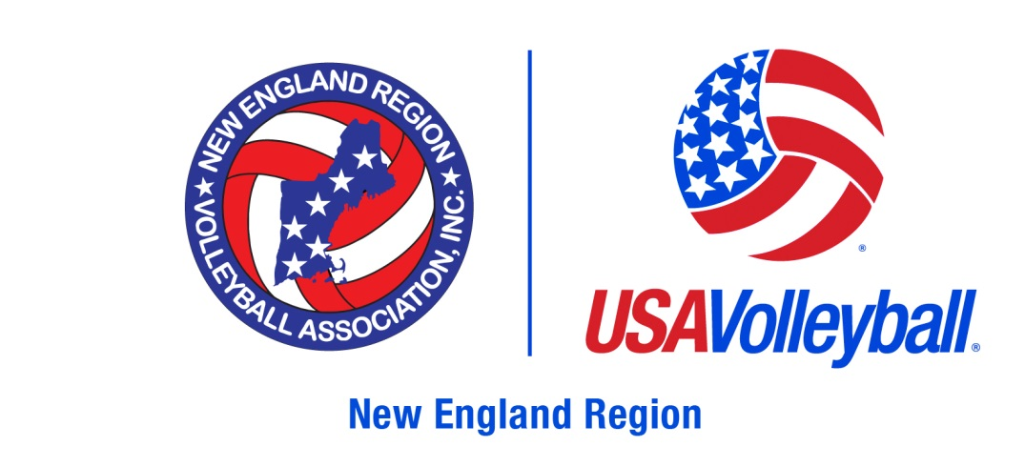

NERVA Sanctioned Outdoor Tournament procedures
All players and coaches MUST be current NERVA members. Once a member, players can sign up on the particular tournament website

All members (Adult and Juniors) MUST present their membership card to the Tournament Director prior to playing in their first match.

Printing your card
- Login to your webpoint account
https://webpoint.usavolleyball.org/wp15/IntraLock/Login.asp
- Choose "print membership card" from the options on the left

USA Volleyball / NERVA Membership Procedures

JUNIORS
If you are a current Full NERVA member you can proceed to the tournament website. You will need to print your membership card and have it with you at check-in (directions above)

If you are not a Full Member (did not play travel volleyball) but were a NERVA member in some fashion - login to your account and renew as a Junior Summer Membership - New England Region for $10. Beginning June 1st you can pay this membership directly by credit card. Login website
https://webpoint.usavolleyball.org/wp15/IntraLock/Login.asp

If you are NEW to NERVA and have never signed up for our region or for USA Volleyball click on this link
https://webpoint.usavolleyball.org/wp/memberships/join.wp?mbr_ChapterID=25971

Prior to June 1st you will need to print out the

COACHES
All coaches MUST be FULL NERVA members and Background checked. This process may take up to 10 days so apply early. Cost of a Full Membership with background check is $53.00. This is a USA and NERVA requirement and there are NO EXCEPTIONS to this. Regardless if have a background check from another source you must still have a certified background check from our company.

USA Volleyball - NERVA Membership Detailed Instructions

If you were a member in New England last year, your info may be on the system. To check, log in to:
https://webpoint.usavolleyball.org/wp15/IntraLock/Login.asp

Ask for a login id; if you are in the system, it will send you an e-mail with a login id and password. Log in, click "Renew Online" (on the left)

If you are not in the system, go to the web address below:
https://webpoint.usavolleyball.org/wp/memberships/join.wp?mbr_ChapterID=25971

Membership Information page will come up.
Fill out all fields marked with an * (required fields), and others you want.
The next page will be the membership Option page.
Choose UNDECIDED for club affiliation.

For Membership Type, choose
Junior Summer Membership for Junior Players
Adult - Yankee for Coaches

Coaches - Select "Roles": coach - Junior roles may require a background screening authorization and FEE. This is required to be a Coach. Fill out the information on the next page.

The next page is a summary to check if the information is correct. If something needs to be corrected, use the back button in the browser.

At the bottom of the page, there are 3 boxes to check. You need to look at the waiver and code of conduct. OPEN THE WAIVERS.

Prior to June 1st or if paying by check – Print the "USAV Waiver and Release of Liability" This will be THE ONLY PAPERWORK you send in with your payment. Then, submit the application.

The next page will state "Your Membership APPLICATION has been successfully submitted".
If you followed directions, you have the printed waiver. Sign the waiver, date it.

Send the signed waiver form along with your registration fee (including background screening fee, if applicable) to:
Judy Katalina, 17 Hickory Ln., Framingham, MA 01701

You will receive, via email, an "Application Confirmation".
Once the Region office receives your signed waiver form and the membership fee, the Region registrar will mark you paid, and you will receive another "Membership Confirmation" e-mail that includes your membership number. Credit Card Memberships are immediate for Juniors. Coaches’ memberships must await Background Check clearance which begins upon receipt of payment and may take up to 10 Days.

